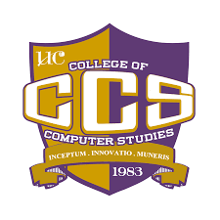



**UNIVERSITY OF CEBU LAPU-LAPU AND MANDAUE**

1. C. Cortes Ave., Looc Mandaue City

COLLEGE OF COMPUTER STUDIES

ENDORSEMENT LETTER

January 27, 2025

Accenture, Inc.

7th Floor Robinsons Cybergate 1

Pioneer St., corner EDSA

Mandaluyong City

Attention:    **Ms. Barbara Jorene** **Chingcuangco**

Candidate Source and Screen Senior Manager

Dear Ms. Chingcuangco,

Greetings!

The College of Computer Studies (CCS) of the **University of Cebu Lapu-Lapu and Mandaue** is looking forward to serving the industry by way of producing globally competitive graduates. Our goal is to give students the much essential industry experience especially in Programming and/or Software Development.

In this connection, I am recommending **Angel Dorie A. Abastillas**, a fourth-year BSIT student to undergo **540 hours of Internship / On-the-job training (OJT)**. The objective of this program is to provide our students with the opportunity to develop confidence, exercise judgment, and to integrate the diversified skills they have learned in theory by way of putting them into practice. We firmly believe that your company is one of those that can help equip our students with the ability to deliver the demands of the industrial world.

Hoping for your positive response.

With warm regards,

**Dr. Janette Q. Tanquis**

OJT Coordinator